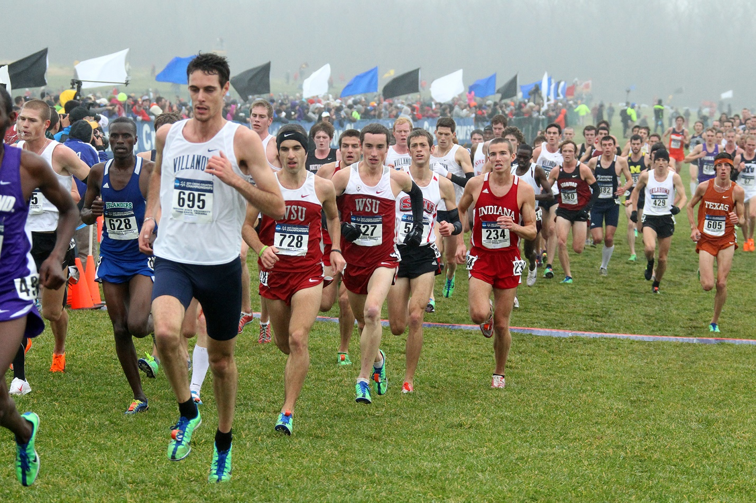
2022 Race Schedule
DATE MEET HOST

Fri/22-Sun/24, July, 2022 Nike CC Camp (8th grade-12th grade) D Lawrence
Saturday, August 13, 2022 Valley Kick-Off T.H. South
Thursday, September 1, 2022 DIII. Invitational Rose- (D Lawrence)
Saturday, September 3, 2022 Home Town Savings Bank State Preview T.H. North
Saturday, September 17, 2022 John McNichols Invitational Indiana State
Wednesday, September 28, 2022 Vigo County Middle School Cross Country Championships
Friday, September 30, 2022 2022 XC Town Twilight/College Division (5-5:20 pm) D Lawrence
Saturday, October 1, 2022 (A.M.) Indiana Middle School Cross Country State Championships
Saturday, October 1, 2022 (P.M.) NIKE XC Town Twilight
Saturday, October 8, 2022 IHSAA Sectional Championships T.H. North
Friday, October 28, 2022 (A.M) Missouri Valley Conference Championships
Saturday, October 29, 2022 IHSAA State Championships VCSC
Friday, November 11, 2022 NCAA Division I Great Lakes Regional Championships
Sunday, November 13, 2022 NIKE CROSS REGIONAL MIDWEST CHAMPIONSHIPS Jeff Martin

Created November 15, 2021-Revised 5/12/2022 Races are subject to change

